**23/02/2024**

**Friday**

**Mandadi Ashok**

**B.tech iv year, IT**

**208X1A1250**

**KALLAM HARANADHAREDDY INSTITUTE OF TECH.**

**Assignment-SQLMAP**

**Step 1 (Definition)**

SQLMap is a tool used for detecting and exploiting SQL injection vulnerabilities in web applications.

It will used for many attack purposes by an ethical hackers and black hackers.

**Step 2 (Installation of SQLMAP)**

Using the GitHub repository to clone the SQLmap in my local system (kali linux)

After this successfully installed in my local machine kali(ashok.mandadi@kali)

**Step 3 (Installation of DVWA & Setup)**

Install and set up DVWA (Damn Vulnerable Web Application) in my local machine kali linux

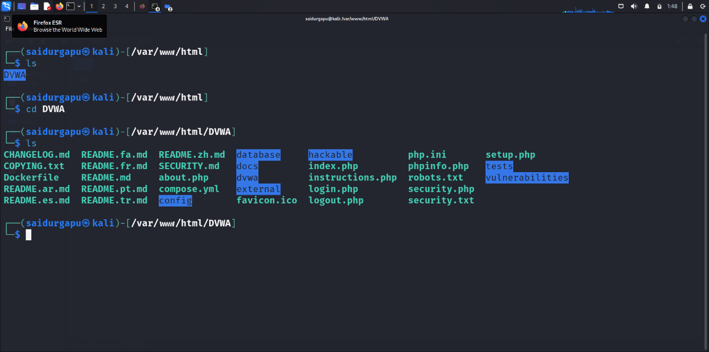

I am using my apache2 server to hosting on local server which Is my 10.0.2.15(local ip address)

Using the fireforx of kali linux machine on url seen in the picture

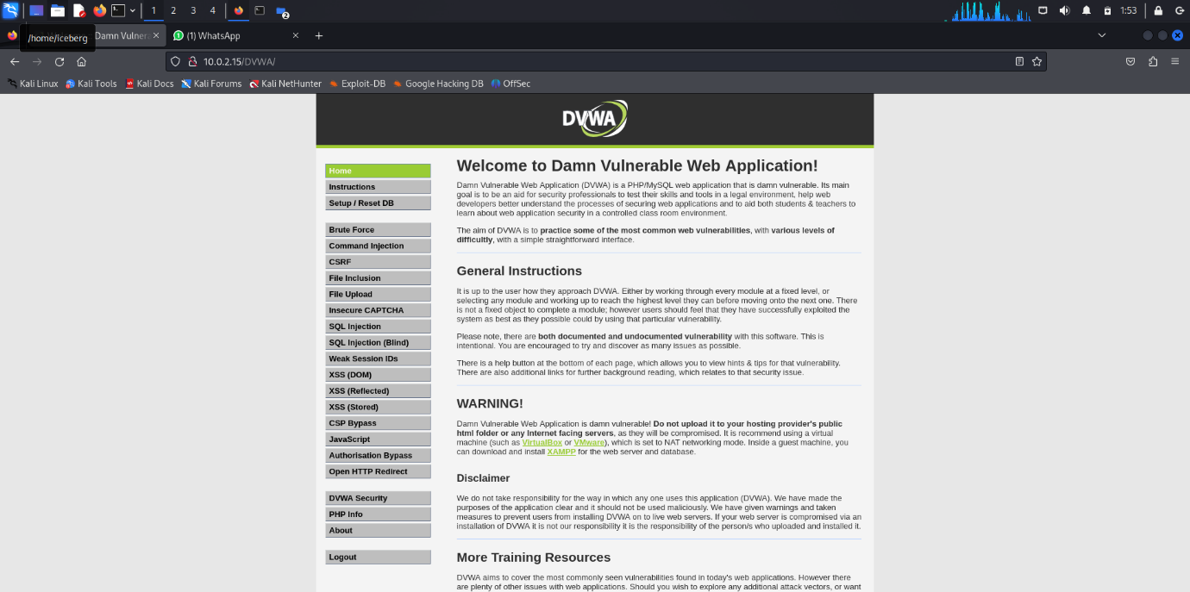

**Step -4 (Performing a Basic SQL Injection Attack)**

I am performing the sql injection in target website of dvwa.In this picture I got url and copy url to sqlmap tool.

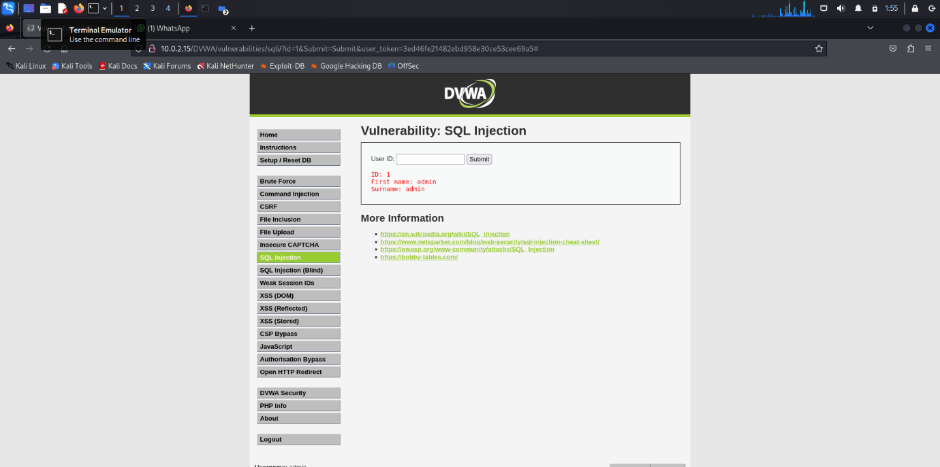

Cookie of my network to perform sql injection on using sql tool

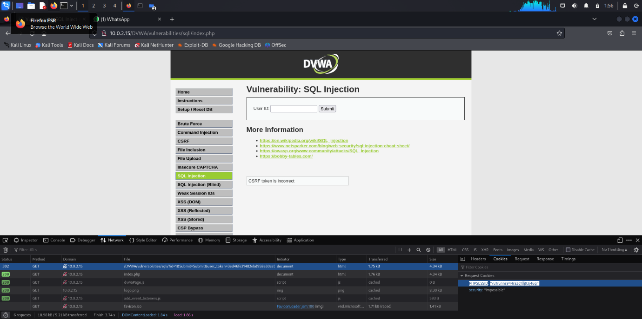

After this we opened Terminal prompt of kalilinux in sqlmap tool

I got url from my local machine (ashok.mandadi@kali):- sqlmap -u 'http://10.0.2.15/DVWA/vulnerabilities/sqli/index.php?id=1&Submit=Submit#' --cookie 'PHPSESSID=vu1runns944ra3q1llj93j4uqr;security=low' –dbs

USING THIS COMMAND IN BELOW PIC:-

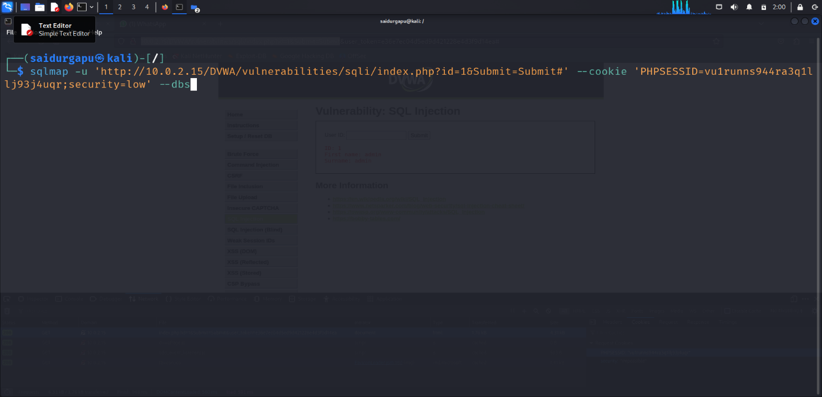

After gathering the databases we got dvwa and information_schema in this pic below in my prompt(ashok.mandadi@kali)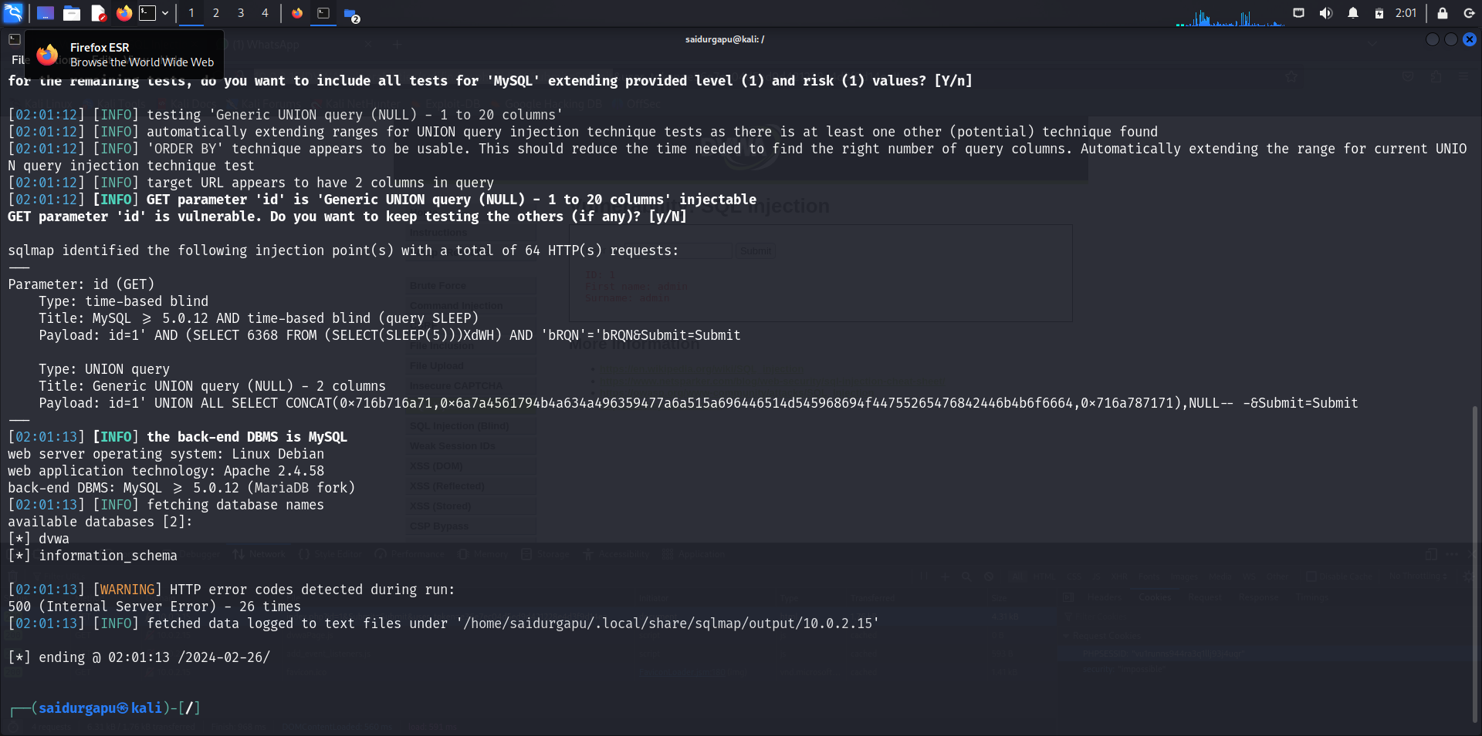After gathering this databases from above pic we use to start access with tables format shown below we got 2 tables with 1.guestbook and 2.users of local web dvwa. We access the users with the following command at end -D dvwa and --tables



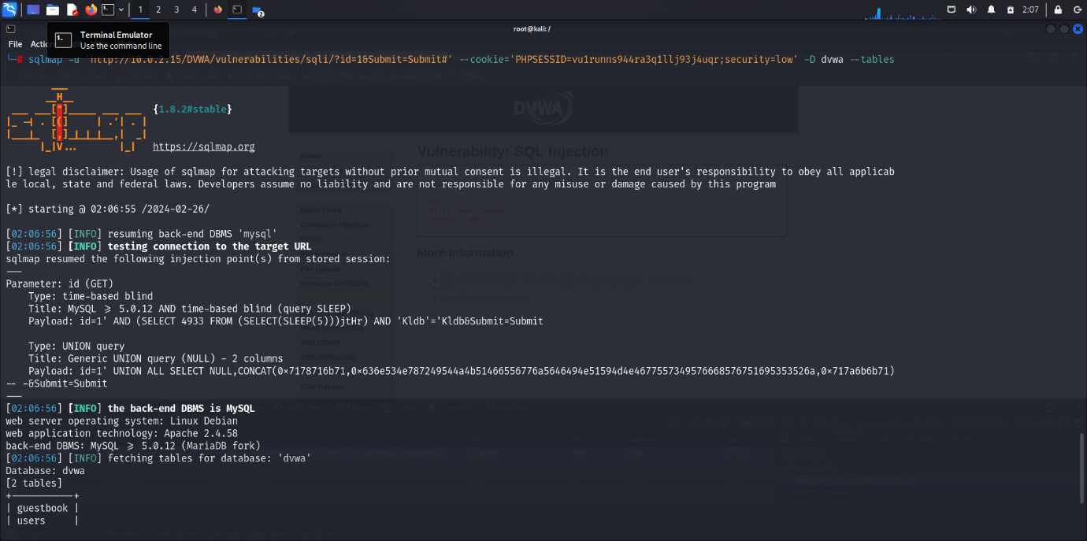

After this we got access the database of users and start sql injection by using the following command -'sql map -u http://10.0.2.15/DVWA/vulnerabilities/sqli/index.php?id=1&Submit=Submit#' --cookie 'PHPSESSID=vu1runns944ra3q1llj93j4uqr;security=low' -D dvwa -T users –dump 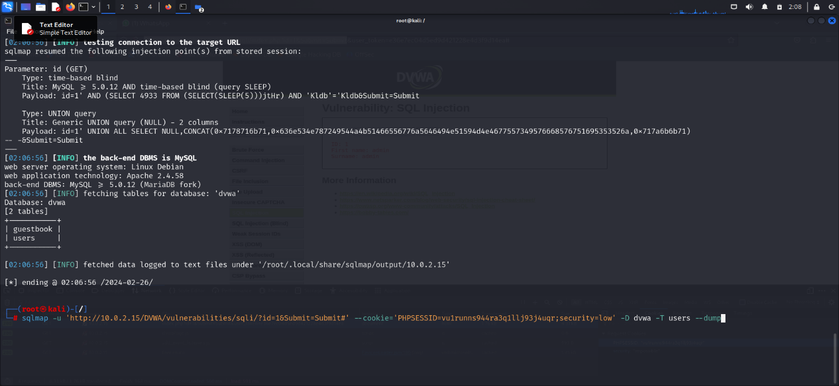

Finally we got output of password on that database list and start md4 hashing passwords using the sqlmap tool.

Here we can see the 5entries of the database of dvwa of users inside and userid and password of that users

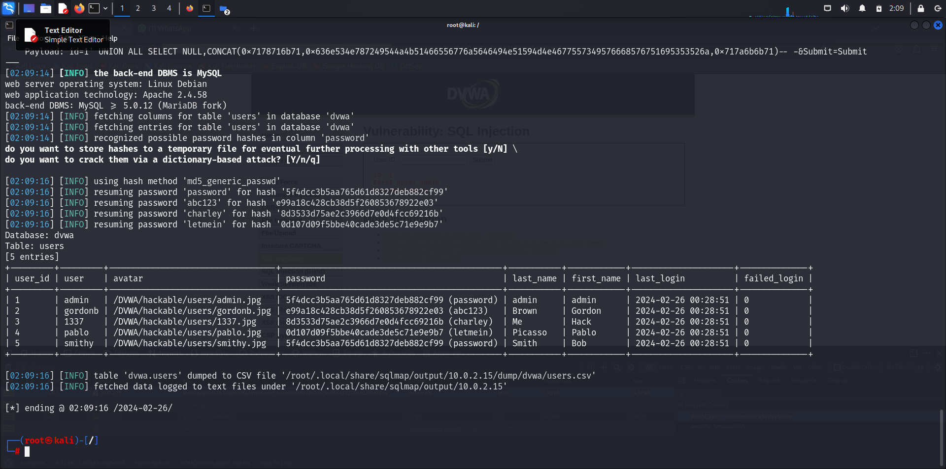

Successfully installed dvwa machinne in my kali linux local (ashok.mandadi@kali) and arranged server using apache2 and database using mysql

So successfully got results output of sql injection performed by the sqlmap tool by look at above pic of result in my local machine kalilinux root (ashok.mandadi@kali)

**potential impact of SQL injection**

Criminals may use it to gain unauthorized access to your sensitive data,customer information, personal data, trade secrets, intellectual property, and more.

For injection attacks specifically, code developers should do things like parameterize queries, encode data, and validate inputs.

THANK YOU

MANDADI ASHOK